

**Title : Workshop-2**

**Module: Object Oriented Design and Programming**

**Module Leader: Er. Subash Bista**

**Lecturer: Er. Raj Prasad Shrestha**

**Student Name: Ritesh Jung Lama**

**Student Number: 220363**

**Group:L5CG4**

Contents

**Activity - 1 (Implementing the concept)** 3

**Code:** 3

**Code Explanation:** 5

**Class Diagram:** 5

**Palindrome** 6

**Code** 6

**Code Explanation:** 7

**Class Diagram** 8

**Prime Number:** 8

**Code:** 8

**Code Explanation:** 9

**Class diagram** 9

# **Activity - 1 (Implementing the concept)**

## **Code:**

public class Animal {

    protected  String name="tommy";

    private String type;

    private int age;

    private String color;

    private String gender;

    private String breed;

    public void setBreed(String breed) {

        this.breed = breed;

    }

    public void setAge(int age) {

        this.age = age;

    }

    public void setType(String type) {

        this.type = type;

    }

    public void setColor(String color) {

        this.color = color;

    }

    public void setGender(String gender) {

        this.gender = gender;

    }

    public String getType() {

        return type;

    }

    public int getAge() {

        return age;

    }

    public String getColor() {

        return color;

    }

    public String getGender() {

        return gender;

    }

    public String getBreed() {

        if (breed==null)

        {

            return ("not set");

        }

        else {

            return breed;

        }

    }

}

class Dog extends Animal{

    public static void main(String[] args) {

        Animal tommy=new Animal();

        tommy.setAge(7);

        tommy.setGender("Male");

        tommy.setColor("Brown");

        tommy.setType("Domestic");

        System.out.println("Age of tommy is "+tommy.getAge());

        System.out.println("Gender of tommy is "+tommy.getGender());

        System.out.println("Color of tommy is "+tommy.getColor());

        System.out.println("Breed of tommy is "+tommy.getBreed());

        System.out.println("Type of tommy is"+ tommy.getType());

    }

}

## **Code Explanation:**

## 

In the code there is a class made called Animal, within it there are variables declared name(protected), type, age, color, and gender which are private and made getter and setter methods for it. Then another class is made called Dog which inherits the class animal then within the dog class all the getter and setters methods are called .

## **Class Diagram:**

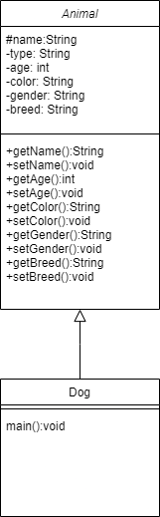

# **Palindrome**

**Code:**

import java.util.Scanner;

public class Palindrome{

    public static void checkPalindrome(String input){

        String reverse="";

        for(int i=input.length()-1;i>=0;i--)

        {

          reverse+=input.charAt(i) ;

        }

        if(input.equalsIgnoreCase(reverse))

        {

            System.out.println("Palindrome");

        }

        else

        {

            System.out.println("Not palindrome");

        }

    }

    public static void main(String[] args) {

        Scanner sc=new Scanner(System.in);

        System.out.println("Enter the input");

        String a=sc.next();

        sc.close();

        checkPalindrome(a);

    }

}

## **Code Explanation:**

In the above code, one public class is declared. Within the class, there is two methods one is main method and another is checkPalindrome method which is static so it can be called without creating the object. checkPalindrome methods reverses the string and check with the original string and returns the result. In main method input is taken using scanner and then the palindrome function is called, sending the value given by the user as parameter.

## **Class Diagram**

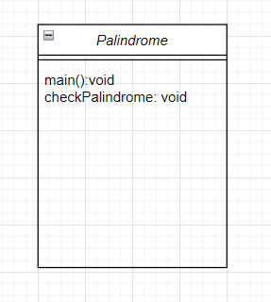

# **Prime Number:**

## **Code:**

import java.util.Scanner;

class PrimeNumber{

    static void checkPrime(int a){

        boolean isPrime=true;

        for (int i=2;i<a;i++)

        {

            if(a%i==0)

            {

                isPrime=false;

            }

        }

        if(isPrime)

        {

            System.out.println(String.valueOf(a)+" is Prime number");

        }

        else

        System.out.println(String.valueOf(a)+" is not Prime number");

    }

    public static void main(String[] args) {

        System.out.println("Enter a number");

        Scanner sc=new Scanner(System.in);

        int a=sc.nextInt();

        sc.close();

        checkPrime(a);

    }

}

## **Code Explanation:**

In the above code, one public class is declared PrimeNumber. Within the class, there is two methods one is main method and another is checkPrime method which is static so it can be called without creating the object. checkPalindrome methods uses loop to check the number and then returns the result. In main method input is taken using scanner and then the prime function is called, sending the value given by the user as parameter.

## **Class diagram**

